Term Paper: Agent Based System/Technology

Angana Chakraborty
Roll No.: 91/CIS/091029
Regn No.: 0063692 of 2006-07

&

Priyanka Das
Roll No.: 91/CIS/091028
Regn No.: 0063688 of 2006-07

Under the Guidance of

Dr. Sankhayan Choudhury

Associate Professor
Department of Computer Science & Engineering
University of Calcutta



M.Sc (Computer And Information Science) 4th Semester 2011
Department of Computer Science & Engineering
University Of Calcutta

Agent Technology: An overview

In this section we have tried to provide an overview of agent technology. In the above section we have discussed how the cloud computing provide scalable, dynamic resource provisioning. However one of the major challenge lies in scalability and automation of these service provisioning. During the project we have studied that mobile agent is able to dynamically add and configure services on the virtual cluster and grid computing. This section we have tried to experiment whether the dynamic properties of agent technology well fulfills the need of efficient service provisioning in cloud environment.

Agent Technology: Definition

An agent is a computer system capable of flexible autonomous action in a dynamic, unpredictable and open environment. Agent technologies are a natural extension of current component based approaches, and have the potential to greatly impact the lives and work of all of us and, accordingly, this area is one of the most dynamic and exciting in computer science today.

About an Agent

Some developers consider agents to be objects, except with more bells and whistles. Then, there are those who see agents and objects as different even though they share many things in common. Both approaches, however, envision using objects and agents together in the development of software systems. In other words, objects and agents are two distinct notions - each having its own particular place in software development.

An agent is defined as “a person whose job is to act for, or manage the affairs of, other people”. In the context of computers, software agents refer to programs that perform certain tasks on behalf of the user. Imagine that you want to go on a trip to a new holiday destination. You contact your travel agent program and describe your preferences and your constraints (such as how much money you are willing to spend, when you want to travel, etc.). The travel agent program suggests where you can spend your holidays after consulting several information sources such as tourist guides and flight schedules and verifying the availability of airline tickets and hotel rooms. When you confirm your destination, the program books the flight tickets and reserves the hotel rooms for you. Thus the software agent acts as your personal assistant.

A software agent is a piece of software, which is situated in an environment, acts on its own and interacts with other similar entities to achieve some design goals [14]. An agent also works pro-actively to pursue certain goals while, at the same time, it responds in a timely fashion to changes that occur in its environment. Agents can interact with other agents and humans with the aim of accomplishing their goals. This agent view provides a well-suited level of abstraction for modeling, an effective way of decomposing, and an appropriate method for dealing with the dependencies and interactions in complex software systems.
The important point here is that the agent-based way of thinking brings a useful and important perspective for system development, which is different from - while similar to - the object oriented way. This paper discusses some of the differences and similarities between agents and objects and lets you decide which viewpoint you want to choose.

Structure of an Agent:
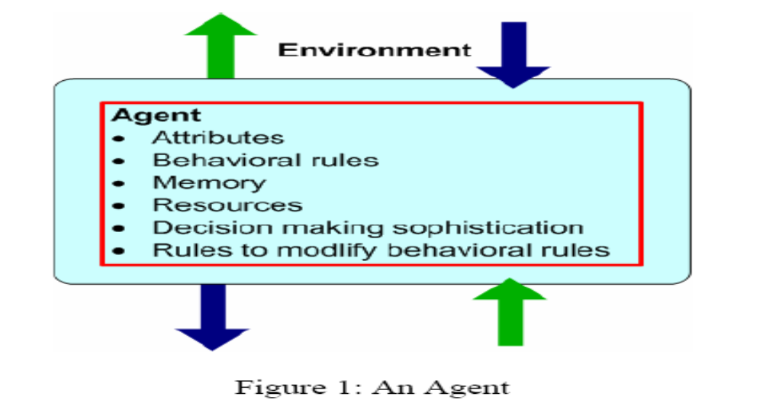

Basic Features that Differentiate Agent from Object

Software agents have their own thread of control, localizing not only code and state but their invocation as well . Such agents can also have individual rules and goals, making them appear like "active objects with initiative". In other words, the agent determines when and how an agent acts. Agents are commonly regarded as autonomous entities, because they can watch out for their own set of internal responsibilities. Furthermore, agents are interactive entities that are capable of using rich forms of messages. These messages can support method invocation as well as informing the agents of particular events, asking something of the agent, or receiving a response to an earlier query. Again as agents are autonomous they can initiate interaction and respond to a message in any way they choose. In other words, agents can be thought of as objects that can say "No" - as well as "Go".[5] Due to the interactive and autonomous nature of agents, little or no interaction is required to physically launch an application. "In the ultimate agent vision, the application developer simply identifies the agents desired in the final application, and the agents organize themselves to perform the required functionality." No centralized

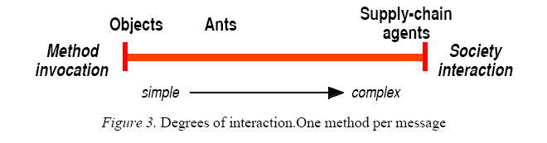

thread or top-down organization is necessary since agent systems can organize themselves.

Characteristics Of Agents:

Software agents have the following properties, which distinguish them from other programs:

Intelligence: Software agents employ techniques from the field of artificial intelligence, which empower them with a fair degree of intelligence and common sense. For example, the travel agent program should realize that people generally do not prefer
travelling by flights that depart or arrive at the airport late in the night and the agent should avoid booking tickets on such flights. The travel agent program should be smart enough to bargain and arrange the trip so that the overall expenditure for the trip is as low as possible without compromising on the user’s preferences.

Autonomy: The agents themselves decide the sequence of actions to be performed to achieve the user’s task. This autonomy enables agents to operate without requiring human intervention. Once the specifications are given to the travel agent, it should be able to proceed on its own to arrange the trip for the user without requiring the user to constantly monitor the agent.

Responsiveness: Agents perceive their environment (which may be the Internet, a collection of other agents, etc.) and respond in a timely fashion to changes that occur in it. At the same time, agents should not simply act in response to their environment, they should be able to exhibit opportunistic, goal-oriented behaviour and take the initiative when appropriate.

Communicative Ability: Software agents should provide a user friendly interface so that the user can easily interact with the agent. Agents are social entities and often communicate and collaborate with one another in order to complete their tasks. For example, the travel agent program of one user must be able to communicate with other travel agents to find out about hotels which customers disliked and avoid such hotels.

Adaptability: Agents learn about the user’s behavior and adapt themselves to suit the user. Consider a search agent that retrieves information for the user from the Internet. The search agent should be able to learn about the type of information the user is interested in and adapt itself to deliver only the relevant information to the user.

Advantages Of Mobile Agent:

- Network Load Reduction: The interactions in a distributed system
are often achieved using communication protocols. These protocols involve transfer of large volumes of data stored at remote hosts over the network to a central processing site resulting in high network traffic. Mobile agents are dispatched to the remote hosts containing the data. The agents perform the computations at the remote hosts and return back with the results. Since computations are moved to the data storage location instead of moving data to the computing location, network load is reduced.

- Overcome Network Latency: Consider a manufacturing plant in which many critical real time systems are controlled through a network. Controlling many systems through a network involves significant delays, which are not acceptable for critical real time systems. To overcome this problem, mobile agents can be directly dispatched from the central controller in the manufacturing plant to the real time systems. The agents act locally and directly execute the controller’s directions.

- Protocol Encapsulation: Protocols enable components of a distributed system to communicate and co-ordinate their activities. However, protocols evolve over a period of time and new features such as better security may be introduced in the protocol. It is a cumbersome task to upgrade the protocol code at all locations in the distributed system. Mobile agents offer a solution to this problem. The mobile agent code can encapsulate the protocol. When a protocol is upgraded, only the mobile agent has to be altered.

- Asynchronous & Autonomous Execution: Mobile agents operate asynchronously. Once a mobile agent is dispatched from the home machine, the home machine can disconnect from the network. The mobile agent executes autonomously without the intervention of the home machine. The home machine can reconnect at a later time and collect the agent.

- Fault Tolerance: Mobile agents react dynamically and autonomously to the changes in their environment, which makes them robust, and fault tolerant. They have the ability to distribute themselves in the network in such a way as to maintain the optimal configuration for solving the particular problem. If a host is being shut down, all agents executing on that machine will be warned and given time to dispatch themselves and continue their operation on another host in the network.

Disadvantages Of Mobile Agent:

The main drawback of mobile agents is the security risk involved in using mobile agents. Security risks in a mobile computing environment are two fold:

- Firstly a malicious mobile agent can damage a host. For example, a virus can be disguised as a mobile agent and distributed in the network causing damage to the host machines that execute the agent.

- On the other hand a malicious host can tamper with the functioning of the mobile agent. Most experts suggest that this risk is far more difficult to deal with.

Applications of ABT:

- Parallel Computing: Solving a complex problem on a single computer takes a lot of time. To overcome this, agents can be written to solve the problem. These agents migrate to computers on the network, which have the required resources and use them to solve the problem in parallel thereby reducing the time required to solve the problem.

- E-Commerce: Mobile agents can travel to different trading sites and help to locate the most appropriate deal, negotiate the deal and even finalize business transactions on behalf of their owners. A mobile agent can be programmed to bid in an online auction on behalf of the user. The user himself need not be online during the auction.

- Mobile Computing: Wireless Internet access is likely to stay slow and expensive. Power consumption of wireless devices and high connection fee deter users from staying online while some complicated query is handled on behalf of the user. Users can dispatch a mobile agent, which embodies their queries, and log off, and the results can be picked up at a later time.

Agent Based Model (ABM)

An Agent Based Model ( also called Multi agent System ) is a class of computational models for simulating the actions and interactions of autonomous agents with a view of assessing their effects on the system as a whole.

In Agent Based Modeling , a system is modeled as a collection of autonomous decision making entities – called agents. [1]

Case Study : HIV Spread Simulation

Different Agents Of The System:[6]

A. Controller agent:
This agent starts the simulation process and controls the creation of all other agents. It provides input to agents. The input are population size, characteristics, behaviors, assumptions about the population, time for completing the simulation and number of executions.
B. Person agents:
These agents represent the individuals in the population . These include the person's gender, HIV-status, type of personality, experience with safe sex, alcohol or drug addiction status, outgoing and having stable relationship.

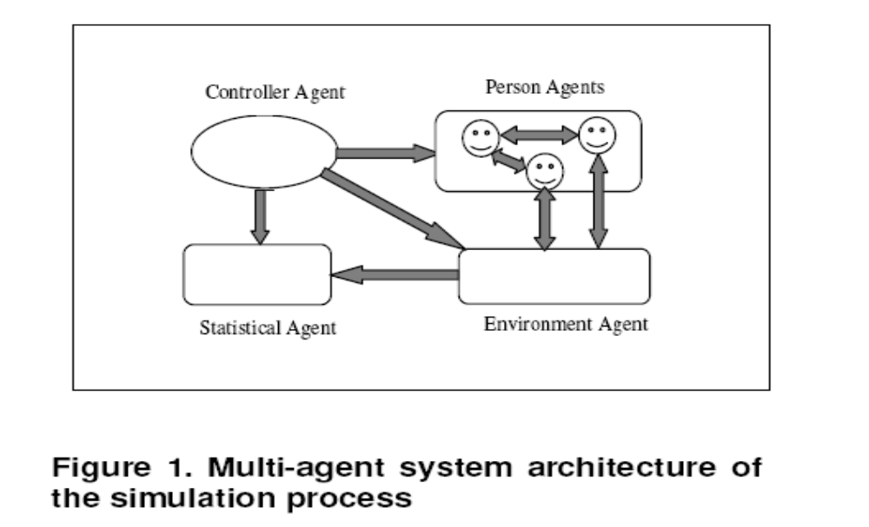

C. Environment agent:
This agent represents the environment in which the Person agents live. The agent has characteristics and behaviors. The properties of the Environment agent can change based on the emergence of new changes which is caused by the interaction of the different Person agents.

D. Statistical agent:
The statistical agent receives the average result of the expected output. The agent contains the results of all the information obtained from the simulation process. It has number of persons living with HIV-positive and number of new HIV infections.

Model Of ABS : AUML

AUML : Agent Based Unified Modeling Language

To build the activity diagram of Agent Based Model, we have used the Agent UML(AUML) notations which has the following basic building blocks defined below:

Agent Class:
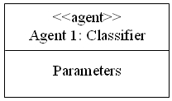

Agents with mobility are called Mobile Agents..

To Specify the actions of the mobile agents:

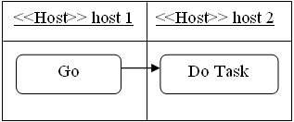

Communication between agents:

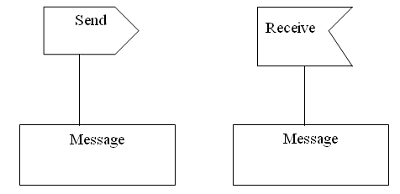

Time Out Notation:

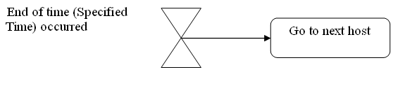

Clone out:
Cloning is another important behavior of mobile agents, which includes several sub activities. This activity allows an agent to clone it first, then to send the cloned agent to another host. This behavior may be repeated in order to send the number of clones required. [4]

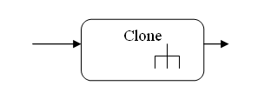

AUML: An Example ABS In Cloud Server

Each of the cloud is a collection of services and the services are being provided from more than one server. The different server may offer the same service but the cost may vary based on the quality of the service. Initially there was an agreement between a client and the service provider. The agreements are identified through some parameters like total allowable cost, minimum response time, security level etc. The cloud can provide the service by offering the service from any of its server without violating the metric value as mentioned by customer. There should be an attempt from a cloud to minimize its own cost for maximizing the profit. This leads to a crucial decision that from which servers the requested services are going to be fired. The cost function is not only dependent on the cost of each service in a specific server rather it depends also on the computation load of that server and the communication cost (as it may vary based on the traffic density in network). The decision has to be adaptive as the later parameters are changing time to time. Thus one may get the different solution from the same SLA requested by a customer in different time.

The Solution Approach

The Mechanism Model Representation
Creates stationary agent
Mobile agent

User request
Creates a mobile agent specifying service and availability requirements

cloud
Takes final decision

servers
Mobile agent sends the status message to the stationary agent

The Mechanism

The mechanism is described based on the proposed model as in Fig 2.1. The steps of the methodology is as follows:

Step I: The Cloud provider accepts a request from the clients with some typical requirements in form of Service Level Agreements (SLA). Here the SLA is identified by the metrics given below:
- Cost ( certain limit provided by the user)
- Response time (upper bound)
- Maximum down time
- Firewall gradation (security)

Step II: Now the service providing cloud has to decide whether the requirement can be satisfied within that cost limit keeping its own profit. If so, it will take decision that which service is to be taken from which server. To do so, the cloud creates a stationary agent and which in turns creates a mobile agent specifying the SLA and service requirements.

Step III: The Mobile agent now moves on each of the server and checks whether the service quality for the requested service matches with the requested parameters or not. If it matches, then the mobile agent returns to the stationary agent the identified service, the corresponding server, the static cost for the requested service, the load of the server at that time instant and the traffic density of the lines lead to the server.

Step IV: On the basis of all these parameters as sent by the mobile agent, the stationary agent takes the final decision .The later mentioned parameters (server load and traffic density) are important to take the decision that sometimes it may not be beneficiary i.e. cost effective for offering a service from a server with high load and the higher chance of network congestion in spite of getting a cheap solution in terms of static cost of that service.

Step V: Again, the service request from the user can be thought of a collection of resources. Among them some are spatially dependent (i.e they are needed to be provided from the same machine) and some other may be temporally related ( i.e precedence with respect to time). we have modeled such relationships using dependency graph and performed DFS to find out the prerequisites of resource Ri. (In chapter 4). From these dependency graphs the stationary agent has to take decision that whether the requested service can be satisfied or not.
If user requests for a resource Ri , then find all the resources that are spatially related with Ri.
If all of them can not be accommodated in the same machine, then report failure (unable to satisfy the service request).Otherwise, trigger them according to the order of temporal dependency . The temporal ordering of firing the services can be obtained by applying the DFS on the temporal dependency graph in bottom up fashion.

Step VI: Then if the request can be satisfied, the cost of the service is calculated as follows:
total_cost=f(static_cost,cpu_load,network_congestion)
where these three factors are given 6:3:1 weight. This ratio can be changed for some particular application. For example, in an application that requires a high amount of data transfer between nodes( such as bioinformatics tools)—the weightage of network_congestion can be increased.

Step VII : The cloud now starts providing the service from the selected server having the least cost.

3.2 Stationary Agent

Receive the request from the cloud service provider

Creates/ invokes mobile agent specifying SLA and service requirements of the user and waits for status message

Receive Receive
Read message
Record message
Send
Send
Compare and take final decision
OK message from mobile agent
STATUS message from mobile agent

Data msg

END msg

ok msg
destroy the mobile agent
AGREE
Check others to find the best one

Final Result fi

3.3 Mobile Agent

Probe each server

Record this

Check whether the server meets SLA and service metrics

Wish to provide service

Yes

Time out

STATUS message to stationary agent
Send

Receive
Message from stationary agent

All servers probed?

no
yes
END message to stationary agent
Send

Stop

References::

[1]Agent Technology: Enabling Next Generation Computing--A Roadmap for Agent-Based Computing by Michael Luck, Peter McBurney and Chris Preist © January 2003, AgentLink II

[2]Mobile Agents Intelligent Assistants on the Internet by Parineeth M Reddy July 2002.

[3]TUTORIAL ON AGENT-BASED MODELING AND SIMULATION PART 2: HOW TO MODEL WITH AGENTS By Charles M. Macal Michael J. North Proceedings of the 2006 Winter Simulation Conference

[4]Modelling Mobile Agent Applications in UML2.0 Activity Diagrams by Miao Kang*, Lan Wang and Kenji Taguchi

[5]Objects and Agents: How do they differ? by James Odell Copyright 1999

[6]Agent-based Modelling: A Case Study in HIV Epidemic byTeweldemedhin Eyob Tshilidzi Marwala Conrad Mueller,School of Computer Science,School of Electrical and Information Engineering University of the Witwatersrand Johannesburg, South Africa

